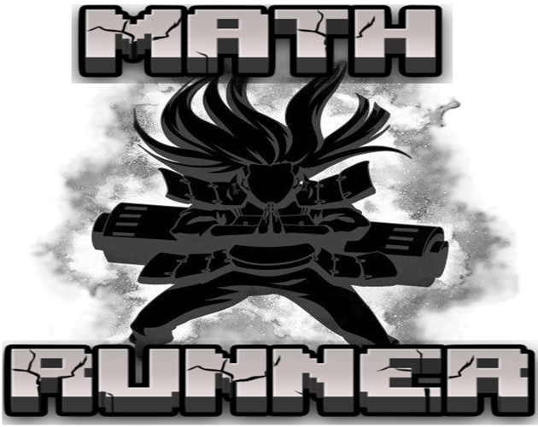  System Design Document: Math Runner Game | Abstract  An adaptive educational platformer that uses real-time emotion detection to personalize math challenges. This document details how the game responds to player frustration, making learning arithmetic a dynamic and engaging experience.  MEMBERS:  -KAMDEU YAMDJEUSON NEIL MARSHALL [ICTU20241386]  - -TUHEU TCHOUBI PEMPEME MOUSSA FAHDIL [ICTU20241393]  - -CHIJIOKE EMMANUEL IZUCHUKWU [ICTU20241760]  - -ANYE DARLINGTON NJI [ICTU20241508]  - -KWETE NGNOUBA RAYAN JUNIOR [ICTU20241377]  Presented to: Eng. TEKOH PALMA

1. Introduction

1.1 Purpose
This document defines the system architecture, components, and design of Math Runner, an educational platformer game that integrates math problem-solving with real-time emotion detection. The purpose of this design is to guide implementation, ensure modularity, and support future extensibility.

1.2 Scope
Math Runner is a Pygame-based application that combines entertainment and education through:
- Side-scrolling platformer gameplay.
- Real-time emotion detection using webcam input and TensorFlow Lite.
- Adaptive difficulty adjustment based on player performance and emotional state.
- Math problem-solving challenges integrated directly into core mechanics.
- Multiple game states and UI screens for user interaction.

1.3 Definitions and Acronyms
- CLAHE: Contrast Limited Adaptive Histogram Equalization
- DNN: Deep Neural Network
- FPS: Frames Per Second
- UI: User Interface
- TFLite: TensorFlow Lite

System Architecture

2.1 High-Level Architecture
Math Runner follows a modular architecture with the following main components:
1. Game Engine Module (Pygame-based core loop and mechanics)
2. Emotion Detection Module (OpenCV + TensorFlow Lite)
3. Math Problem Generation Module (equation creation and validation)
4. UI/UX Module (menus, overlays, screens)
5. Audio Management Module (music, effects, adaptive feedback)
COMPONENT DIAGRAM 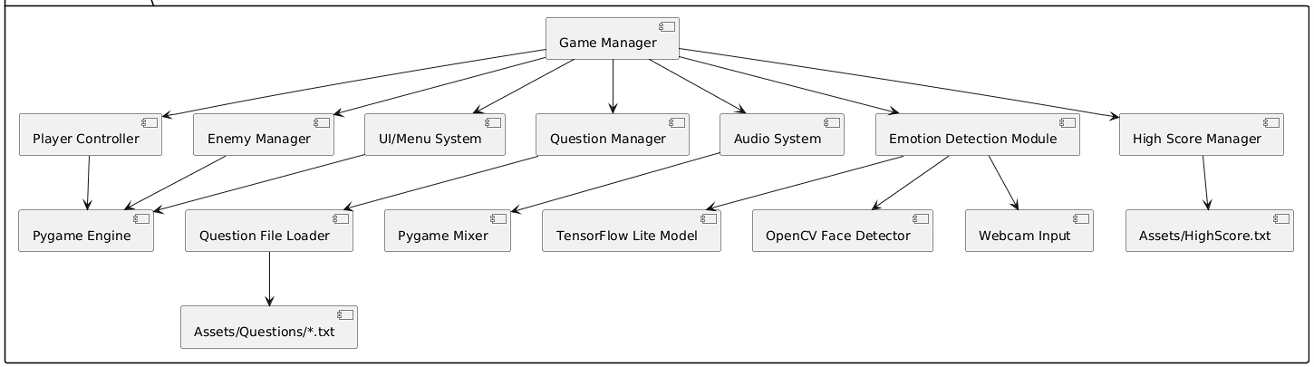

3. Use Case Diagram

Actors
Player

Use Cases
- Play Game
- Solve Math Problems
- Control Character Movement
- View Game Menu
- Adjust Settings
- View High Scores
- Receive Emotion-Based Hints
- Experience Adaptive Difficulty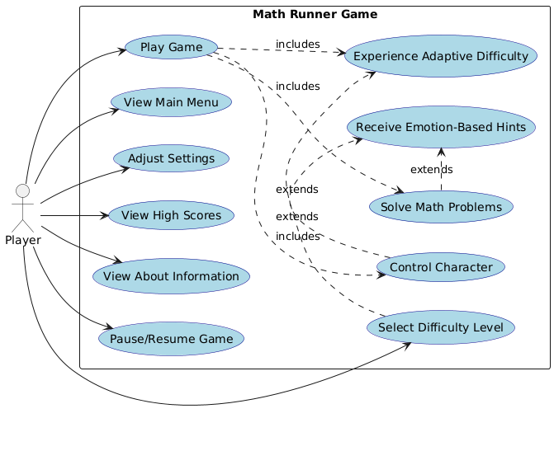
4. Class Diagram

Main Classes
- Animation – Handles player animations and state transitions.
- Enemy – Governs enemy AI, movement, and collision.
- Frame – Manages animation frames.
- Background – Controls scrolling backgrounds.
- EquationC – Generates math problems and validates answers.
- Heart – Tracks player health/lives.
- Button – UI button interaction handler.
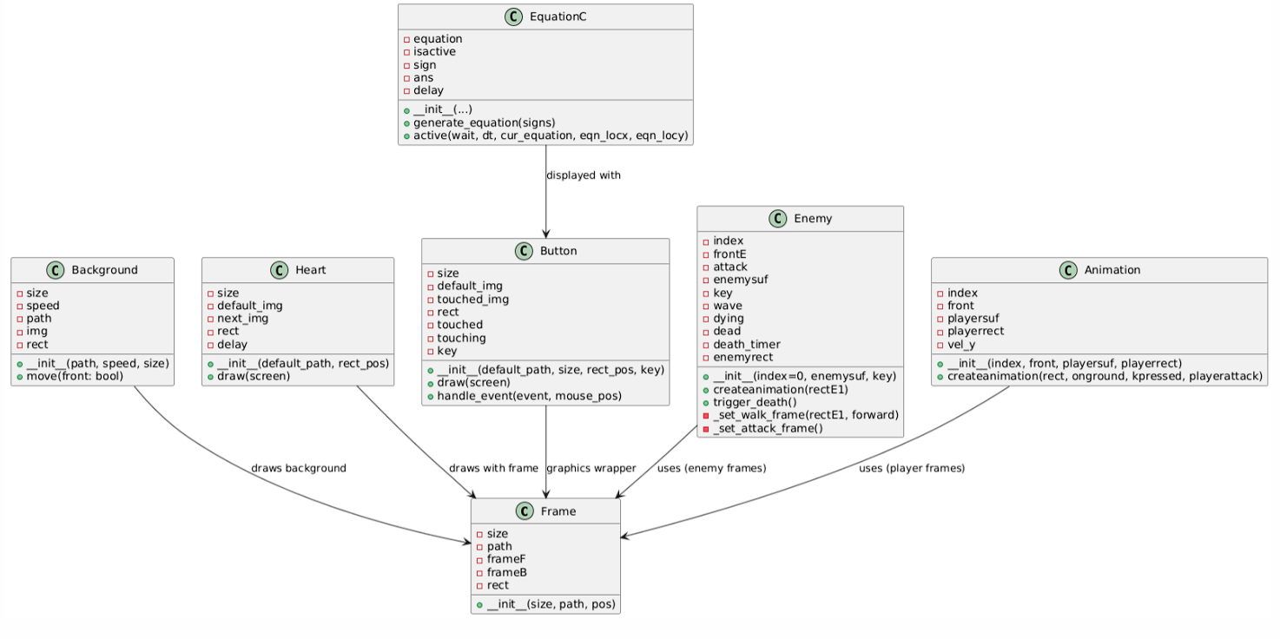

5. Sequence Diagrams

5.1 Game Initialization Sequence
Pygame init → Load assets/resources → Launch emotion detection thread → Show main menu 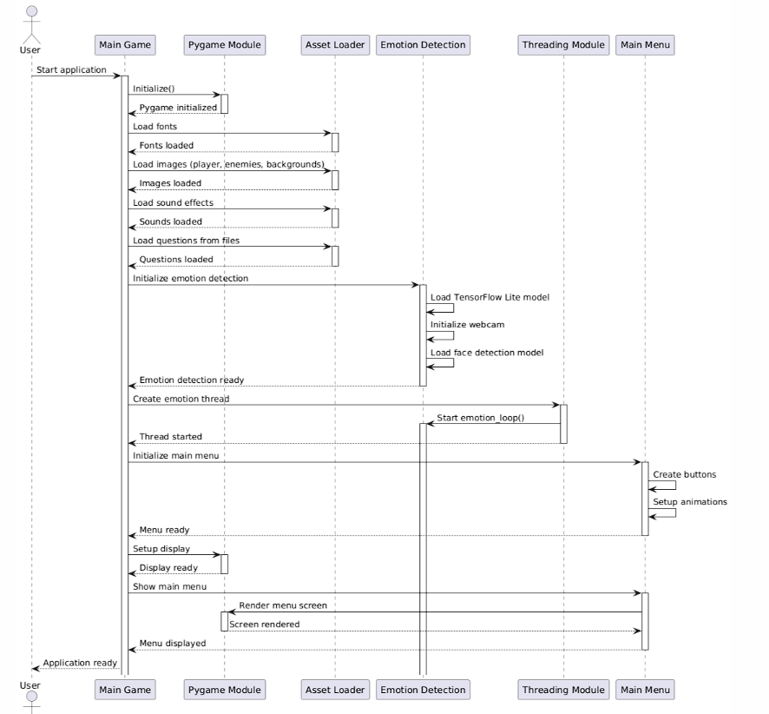

5.2 Gameplay Sequence
Player movement → Enemy collision → Math problem prompt → Answer validation → Score/life update 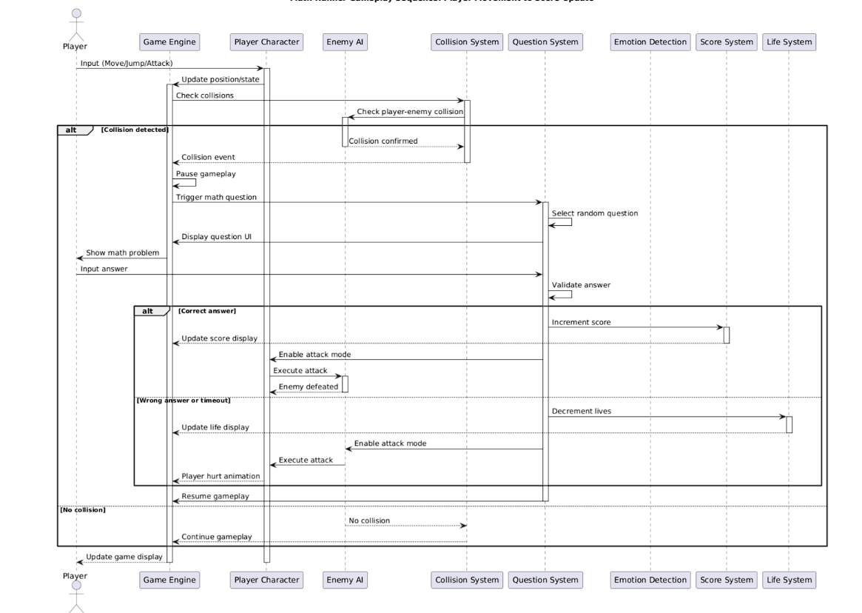

5.3 Emotion Detection Sequence
Webcam capture → Face detection → Image preprocessing → Emotion classification → Difficulty/hint adjustment 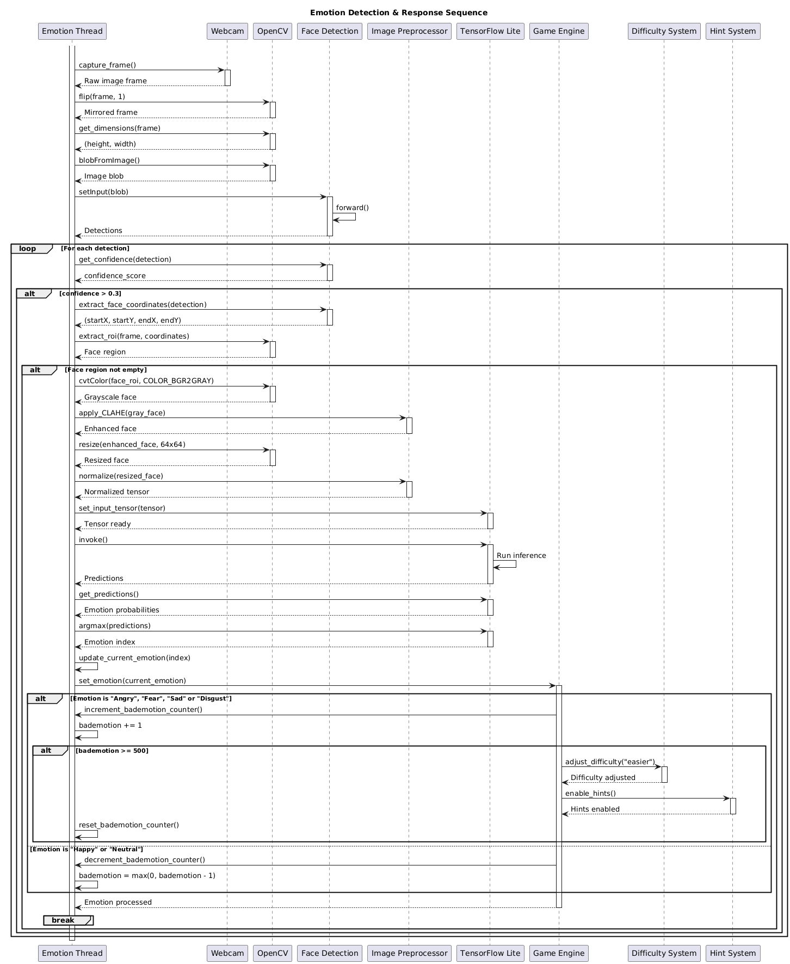

5.4 Adaptive Difficulty Sequence
Track performance + emotion → Evaluate thresholds → Adjust difficulty → Provide hints if frustration detected 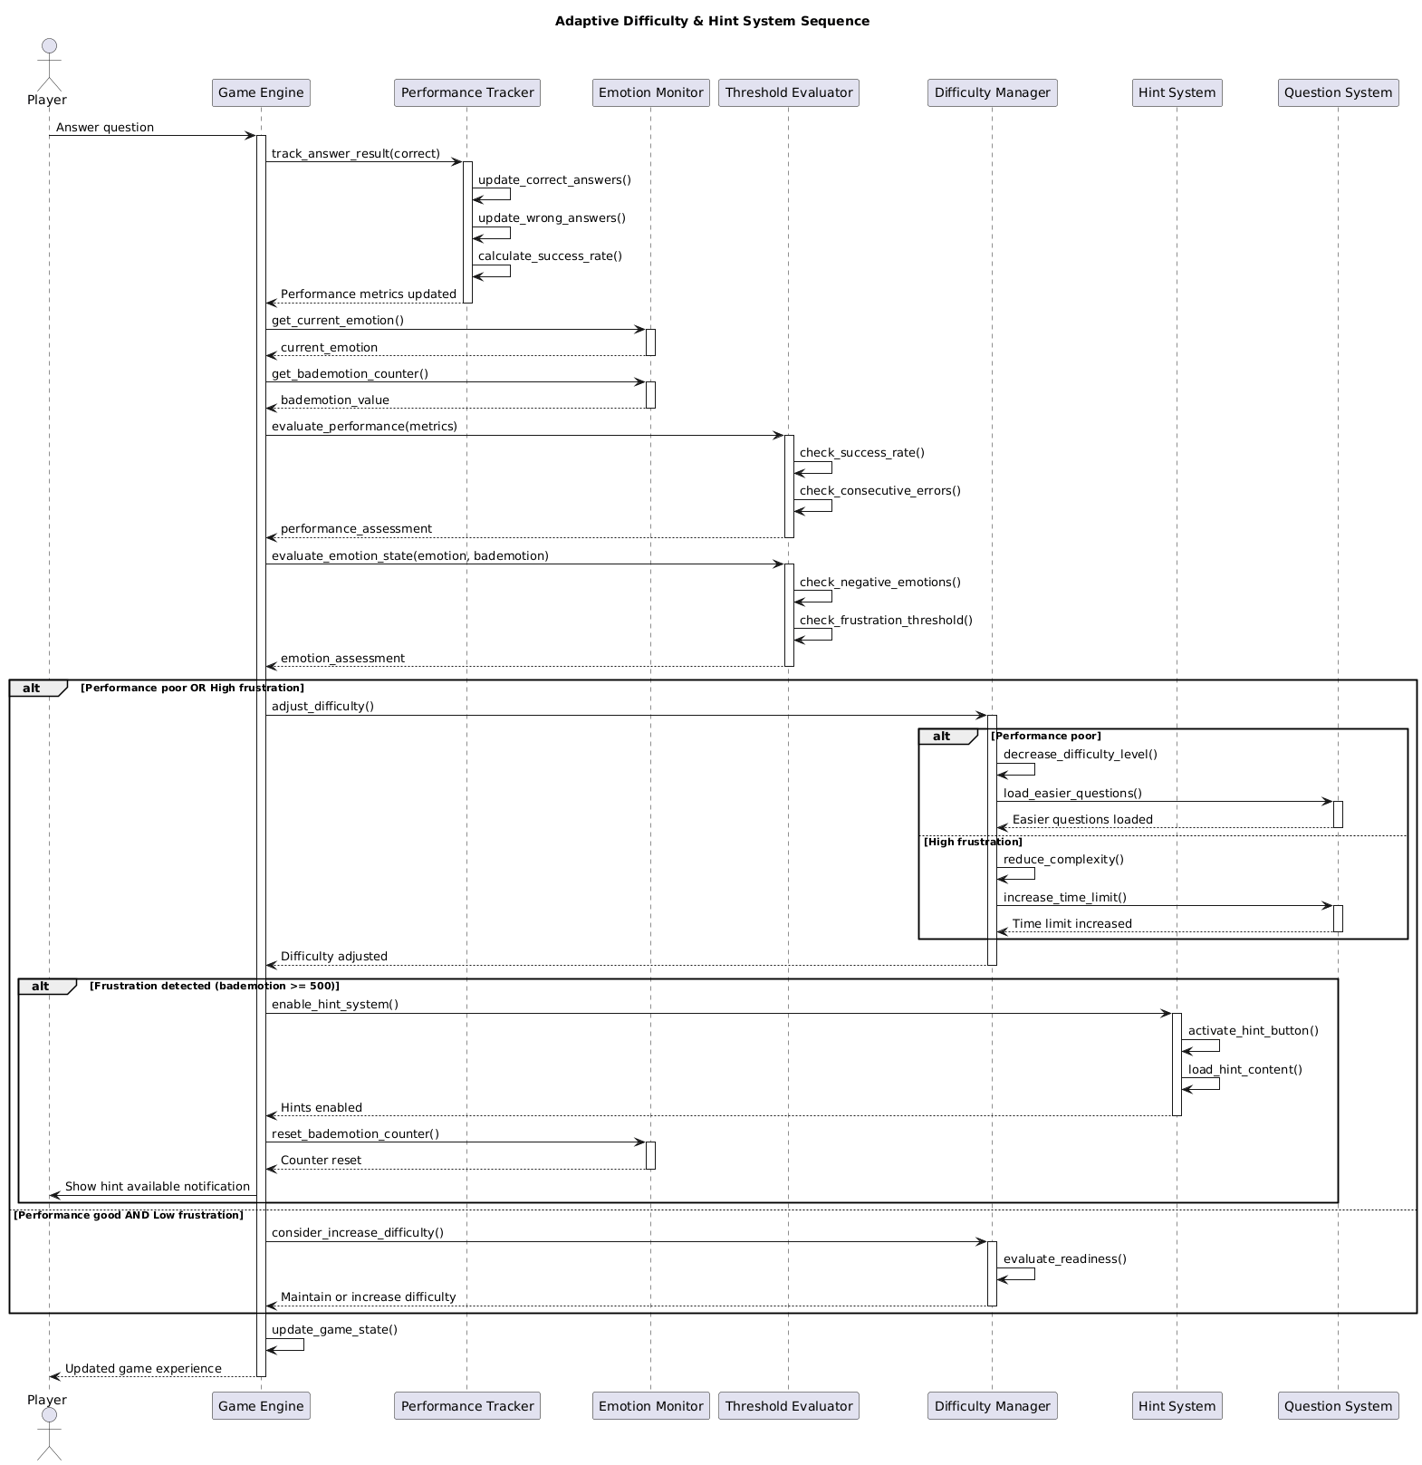

5.5 UI Navigation Sequence
(Sequence: Menu interaction → Screen transitions → Settings adjustment → Game state changes)
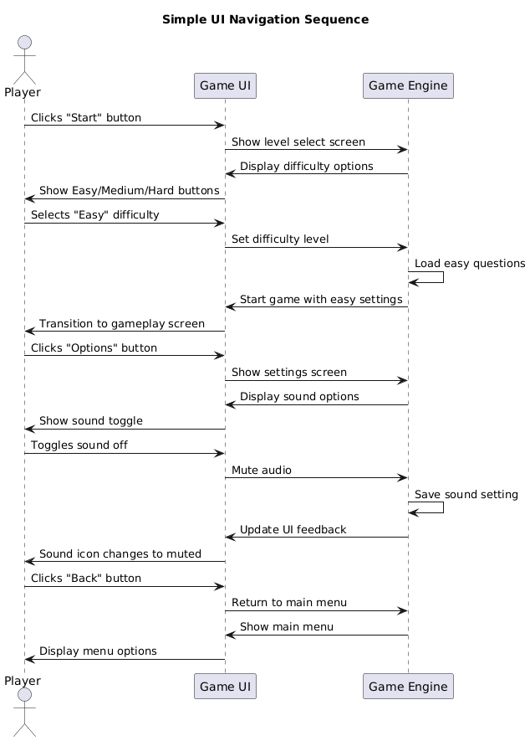

6. Database Design

6.1 Data Storage
- High Scores: Stored in Assets/HighScore.txt
- Math Questions: Stored in text files by difficulty level
- Emotion Model: Pre-trained .tflite model stored in Assets/

6.2 Data Structures
game_state = {
"current_screen": "menu",
"player": {
"score": 0,
"lives": 5,
"position": (0, 0),
"state": "idle" # idle, running, jumping, attacking
},
"emotion": {
"current": "neutral",
"frustration_counter": 0
},
"difficulty": "easy",
"enemies": [],
"current_question": {}
}

7. Interface Design

7.1 External Interfaces
- Webcam Interface: OpenCV (real-time emotion detection)
- File System: For scores, questions, and logs
- Audio System: Pygame mixer for sound/music

7.2 User Interfaces
- Main Menu Screen
- Gameplay Screen
- Math Question Screen
- Options Screen
- Game Over Screen
- About Us Screen

8. Product Backlog
User Story ID | User Story | Acceptance Criteria | Priority | Initial Estimate (days) | Adjustment Factor | Final Estimate (days)
1.1 | As a player, I want to control my character so I can navigate the game world. | Player can move left, right, jump, and attack smoothly. | High | 2.5 | 0.8 | 2
1.2 | As a player, I want enemies to appear so that the game feels challenging. | Enemies spawn, move, attack, and collide with player. | High | 4 | 0.75 | 3
1.3 | As a player, I want the game to track my score and lives. | Score increments, lives decrease, high score saves to file. | High | 2 | 1.0 | 2
2.1 | As a player, I want math questions to appear when I face enemies. | Questions load, answers accepted, feedback shown. | High | 1.5 | 1.33 | 2
2.2 | As a player, I want hints to appear when I’m struggling. | Hints appear after repeated wrong answers or frustration. | Medium | 4 | 0.5 | 2
2.3 | As a player, I want the game to change difficulty dynamically. | Level changes when poor performance or hints triggered. | Medium | 2 | 1 | 2
3.1 | As a player, I want the game to detect my face emotion. | Webcam runs, emotion detected in real-time. | High | 10 | 0.6 | 6
3.2 | As a player, I want the game to react to frustration. | Bad emotion counter triggers hints or difficulty drop. | High | 5 | 0.6 | 3
4.1 | As a player, I want a menu system (Start, Options, About Us). | Menu buttons functional, About Us page loads. | Medium | 3 | 1.0 | 3
4.2 | As a player, I want smooth animations. | Player, enemy, and background animations run smoothly. | Medium | 3.2 | 1.25 | 4
5.1 | As a player, I want background music. | Music plays in menu and game, can pause/resume. | Medium | 2 | 0.5 | 1

10. Sprint Backlog
Release | Title | Sprint | User Story ID | User Story | Duration (days) | Dates (Start – End)
Release 1 | Core Gameplay & Learning Mechanics | Sprint 1 | 1.1 | Control character (move, jump, attack) | 2 | Aug 10 – Aug 11
 |  | Sprint 1 | 1.2 | Enemies spawn, move, attack | 3 | Aug 12 – Aug 14
 |  | Sprint 1 | 1.3 | Track score and lives | 2 | Aug 15 – Aug 16
 |  | Sprint 1 | 2.1 | Math questions on enemy encounters | 3 | Aug 17 – Aug 19
 |  | Total Sprint 1 = 10 days |  |  |  | Aug 10 – Aug 19
Release 2 | Core Gameplay & Learning Mechanics | Sprint 2 | 2.2 | Hints appear after struggles | 2 | Aug 20 – Aug 21
 |  | Sprint 2 | 2.3 | Dynamic difficulty adjustment | 2 | Aug 22 – Aug 23
 |  | Sprint 2 | 3.1 | Face emotion detection | 6 | Aug 24 – Aug 29
 |  | Sprint 2 | 3.2 | React to frustration (hints/difficulty drop) | 3 | Aug 30 – Sept 1
 |  | Total Sprint 2 = 13 days |  |  |  | Aug 20 – Sept 1
Release 3 | User Experience & Enhancements | Sprint 3 | 4.1 | Menu system (Start, Options, About Us) | 3 | Sept 2 – Sept 4
 |  | Sprint 3 | 4.2 | Smooth animations | 4 | Sept 5 – Sept 7
 |  | Sprint 3 | 5.1 | Background music (pause/resume) | 1 | Sept 8
 |  | Total Sprint 3 = 8 days |  |  |  | Sept 2 – Sept 8

11. Testing Strategy

11.1 Unit Testing
- Verify EquationC outputs
- Validate collision detection
- Test individual UI elements

11.2 Integration Testing
- Ensure emotion detection updates game difficulty
- Validate math system integration into gameplay
- Test seamless screen transitions

11.3 Performance Testing
- Stress test FPS under multiple enemies
- Memory profiling under prolonged gameplay
- Benchmark emotion detection latency

12. Deployment

12.1 Hardware Requirements
- - Webcam (required for emotion detection)
OS: Windows 10 / 11
- Processor: Intel i3 or equivalent
- Memory: 4 GB RAM
- Graphics: Integrated graphics
- Storage: 500 MB available space
12.2 Installation Process
- Extract the file
- Run Mathrunner.exe (the installer).
- Follow the on-screen steps to install Math Runner.
- Once installed, launch the game from your Start Menu or the desktop shortcut (if you chose to create one)

13. Maintenance

13.1 Error Handling
- Fallback mode if webcam unavailable
- Graceful handling of missing assets
- Error logs stored in logs/

13.2 Update Strategy
- Swap in new math datasets easily
- Replace or improve TFLite models
- Adjust difficulty scaling via configuration

14. Conclusion

Summary
Math Runner merges fun gameplay with adaptive learning. By combining platformer mechanics, math challenges, and emotion-driven feedback, it creates a personalized educational experience. The modular design ensures maintainability, scalability, and room for future innovation.
---
Document Version: 1.0
Last Updated: 2025-09-09

